Experiment No. | 9
Aim | String matching algorithms ( Rabin-Karp and Naive)
Name | Sakshi D Lonare
UID No. | 2021300069
Class & Division | Comps SE A

Algorithm:-

- Rabin Karp Algorithm:-
- Initially calculate the hash value of the pattern.
- Start iterating from the starting of the string:
- Calculate the hash value of the current substring having length m.
- If the hash value of the current substring and the pattern are same check if the substring is same as the pattern.
- If they are same, store the starting index as a valid answer. Otherwise, continue for the next substrings.
- Return the starting indices as the required answer.

- Naïve Algorithm:-
Naive (T, P)
1. n ← length [T]
2. m ← length [P]
3. for s ← 0 to n -m
4. do if P [1.....m] = T [s + 1....s + m]
5. then print "Pattern occurs with shift" s

Program:-

- Rabin Karp:-
#include <stdio.h>
#include <string.h>
#define d 256

void RK(char p[], char t[], int q)
{
int T = strlen(t);
int P = strlen(p); //holds the length of the pattern and string
int hp = 0;
int ht = 0; //hash values for pattern and string
int i, j;
int h = 1;

// calculate h = d^(P-1) % q
for (i = 0; i < P - 1; i++)
h = (h * d) % q;

// calculate the initial hash values for pattern and string
for (i = 0; i < P; i++) {
hp = (d * hp + p[i]) % q;
ht = (d * ht + t[i]) % q;
}

printf("Hash value of pattern: %d\n", hp); // print hash value of pattern

int count = 0; // number of spurious hits
for (i = 0; i <= T - P; i++) {
if (hp == ht) {
for (j = 0; j < P; j++) {
if (t[i + j] != p[j])
break;
}
if (j == P) {
printf("Pattern found at index %d\n", i+1);
} else {
count++;
}
}
if (i < T - P) {
// calculate the hash value for the next window in the text
ht = (d * (ht - t[i] * h) + t[i + P]) % q;
if (ht < 0)
ht += q;
}
}
printf("Number of spurious hits: %d\n", count);
}

int main()
{
char t[30];
char p[30];
int q;
printf("Enter Text: ");
gets(t);
printf("Enter Pattern: ");
gets(p);
printf("Enter q: ");
scanf("%d",&q);
RK(p, t, q);
return 0;
}

- Naïve Algorithm:-
#include <stdio.h>
#include <string.h>

int main()
{
char t[30];
char p[30];
int i, j;
printf("Enter Text:- ");
gets(t);
printf("\nEnter Pattern:- ");
gets(p);
int m = strlen(p);
int n = strlen(t);
int max_shifts = n - m + 1;

for (i = 0; i <= max_shifts; i++) {
for (j = 0; j < m; j++) {
if (t[i + j] != p[j])
break;
}
if (j == m) {
printf("Pattern found at index %d\n", i+1);
}
}
printf("Maximum possible shifts: %d\n", max_shifts);
return 0;
}

Output:- 1) Rabin Karp
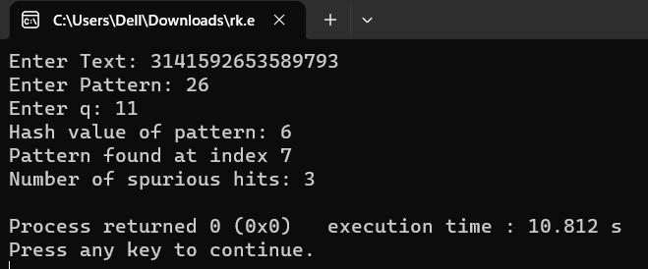
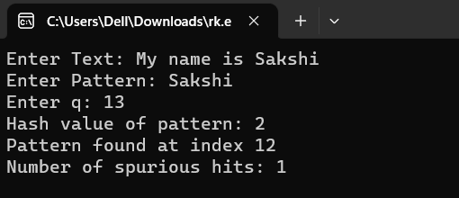

- Naïve Algorithm
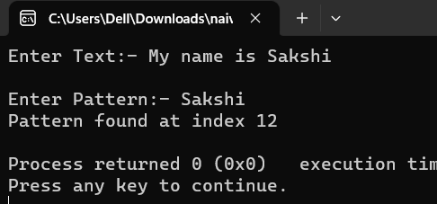
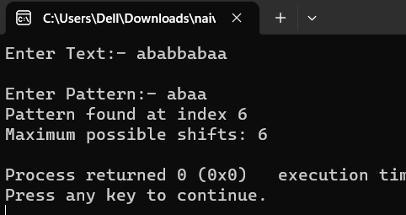

Conclusion: I learnt how the String Matching Algorithms work like, and also found out that the worst-case time complexity for naïve algorithm and Rabin-Karp algorithm is O(m*(n-m+1)) , where m is the length of the pattern and n is the length of the text. Though, Rabin Karp is much faster than naïve algo for large pattern and text lengths.

